

ASSET VERIFICATION AND RECORDING TOOL KIT


Plot 31, Bukoto Street
P.O Box 7657, Kampala, Uganda
+256 (0) 39 2000216/0772525235
email: cpa@cpa.ug

www.cpa.com

August to September 2026

VERIFICATION DETAILS

NAME OF THE REGION: | NORTHERN REGION
SUB-REGION: | LANGO-SUB REGION
Name of Local Government | ALEBTONG DISTRICT LOCAL GOVERNMENT
VERIFIER PARTICULARS
Full name | AGANYO MERCY
Contact/ email and Telephone | 0786551826
Supervisor/ Sub team leader
Name | MR.DENIS
Contact | 0779622063
Date of submission | 29TH AUGUST 2026

NAME OF HEALTH CENTER ADWIR HEALTH CENTRE III

1a | Does the Facility have a record of all assets provided under UgIFT.  (Obtain a record and verify if it has the costs and numbers supplied | YES
1b | If Not ask how many were supplied and when.

2 | How does this facility Maintain (repair/service/replace) the assets provided under Ugift
Incase of any damage, repair and servicing, Adwir Health Center III uses 10% of the primary Health Care to service the damages and maintain the equipment in a good condition.

3 | Does the facility take regular record about functionality/ or breakdown of the assets provided?

Yes, Adwir Health Center III often conducts regular checks on the equipment that were provided to ensure that they are working well as intended. Any damages are recorded for better service delivery and making informed decisions

4 | How has the UgIFT support helped in service delivery in the area, any issues, challenges and any recommendations for better program implementation.

It has improved the health of the community members since many service are now accessible to the locals for example expectant mothers can now put to bed within the facility due to delivery beds provided. However there is no power to run some of the equipment that were provided therefore some equipment are still in the store.

Recommendation. UGIFT should support with building a fence for the health facility’

PROCEED TO VERIFICATION AFTER THIS DISCUSSION

Health Centre checklist

NAME OF LG: ALEBTONG DISTRICT LOCAL GOVERNMENT. NAME OF HEALTH FACILITY: ADWIR HEALTH CENTER III

Equipment/ Item | Department | Asset Number | Item  Description | Life in Months | Tag Number ( engrave no.) | Date Of Purchase | Date Placed In Service | Recoverable cost | Cost | Acc Dep Cost | Net Book Value | Ytd Deprn | Equipment status | Remarks
B.P. Machine, Digital (2) | MCH |  | Digital | 26 months | Not engraved | June 2023 | OCT 2024 |  |  |  |  |  | Non- functional | They got spoilt.
B.P. Machine (Aneroid wall mounted) (2) | Store |  | Manual | 12 months | Not engraved | June 2023 | OCT 2024 |  |  |  |  |  | Non-functional | They all got spoilt because they were sub-standard
Autoclave 20 Liters.,Duo Operated (2) | MCH  WARD |  | Metallic | 60 | Not engraved | June 2023 | Oct 2024 |  |  |  |  |  | Functional | Good working condition
Bowl, Kick (1) | MCH |  | Metallic | 60 |  | June 2023 | Oct 2024 |  |  |  |  |  | Functional | Good working condition.
Bowl Stand | --- | -- | --- | --- | --- | - | ---- | --- | --- | --- | --- | --- | --- | ---
Counting chamber Neubauer- Improved (2) | Wards |  | Plastic in nature | 60 |  | June 2023 | Oct 2024 |  |  |  |  |  | Functional | Good condition.
Cupboard Steel, Lockable (6) | MCH  LAB |  | Metallic | 70 | Not engraved | June 2023 | Oct 2024 |  |  |  |  |  | Functional | Good working Condition.
Drip Stand (9) | MCH  WARD |  | Metallic | 60 | Not engraved | June 2023 | Oct 2024 |  |  |  |  |  | Functional | Good working condition.
ESR Stand (1) | MCH |  | Glass in nature | 36 | Not engraved | June 2023 | Oct 2024 |  |  |  |  |  | Functional | Good working condition.
Examination Couch (4) | MCH  OPD  WARDS |  | Metallic | 60 | Not engraved | June 2023 | Oct 2024 |  |  |  |  |  | Functional | Good working condition
Examination light,LED (3) | MCH  OPD |  | Plastic | 60 | Not engraved | June 2023 | Oct 2024 |  |  |  |  |  | Functional | Good working condition
Glucometer (1) | LAB |  | Digital | 12 | Not engraved | June 2023 | Oct 2024 |  |  |  |  |  | Non-functional | Its faulty
Haemoglobin Meter, Digital (1) | LAB |  | Digital | 60 | Not engraved | June 2023 | Oct 2024 |  |  |  |  |  | Functional | Good working condition
Height Meter (2) | MCH  OPD |  | Metallic | 60 | Not engraved | June 2023 | Oct 2024 |  |  |  |  |  | Functional | Good condition
Instrument Trolley (4) | MCH  WARDS |  | Metallic | 60 | Not engraved | June 2023 | Oct 2024 |  |  |  |  |  | Functional | Good working condition
Microscope Binocular (1) | LAB |  | Metallic and digital | 80 | Not engraved | June 2023 | Oct 2024 |  |  |  |  |  | Functional | Good working condition
Otoscope (1) | OPD |  | Metallic | 60 | Not engraved | June 2023 | Oct 2024 |  |  |  |  |  | Functional | Good working condition
Patient Screen (5) | MCH  WARDS  STORE |  | Metallic and plastic | 36 | Not engraved | June 2023 | Oct 2024 |  |  |  |  |  | Functional | Good working condition.
Patient Trolley (1) | MCH |  | Metallic | 60 | Not engraved | June 2023 | Oct 2024 |  |  |  |  |  | Functional | Good working condition
Refrigerator, Basic (2) | LAB  MCH |  | Metallic | 60 | Not engraved | June 2023 | Oct 2024 |  |  |  |  |  | Functional | Good working condition
Stethoscope (8) | OPD MCH |  | Plastic and metallic | 12 | Not engraved | June 2023 | Oct 2024 |  |  |  |  |  | Non-functional | They got spoilt
Stop Watch (1) | OPD |  | Plastic | 12 | Not engraved | June 2023 | Oct 2024 |  |  |  |  |  | Non-functional | They got spoilt
Stretcher (2) | MCH  OPD |  | Metallic with leather | 36 | Not engraved | June 2023 | Oct 2024 |  |  |  |  |  | Functional | Good working condition
Stove, Gas (2) | MCH |  | Metallic | 36 | Not engraved | June 2023 | Oct 2024 |  |  |  |  |  | Functional | Good working condition
Weighing Scale with Height Meter, Adult (2) | OPD  MCH |  | Metallic | 24 | Not engraved | June 2023 | Oct 2024 |  |  |  |  |  | Functional | Good working condition
Weighing Scale, Infant(2) | MCH |  | Plastic | 36 | Not engraved | June 2023 | Oct 2024 |  |  |  |  |  | Functional | Good condition
Weighing Scale, Toddler (1) | MCH |  | Metallic | 36 | Not engraved | June 2023 | Oct 2024 |  |  |  |  |  | Functional | Good working condition
Wheel Chair (4) | Store |  | Metallic with leather | 36 | Not engraved | June 2023 | Oct 2024 |  |  |  |  |  | Non- functional | They were brought without tyres
Audio Visual Equipment (1) | OPD |  | Digital | 60 | Not engraved | June 2023 | Oct 2024 |  |  |  |  |  | Functional | Good working condition
Medical Waste Bin (20) | MCH  LAB  WARDS  OPD |  | Metallic and plastic | 24 | Not engraved | June 2023 | Oct 2024 |  |  |  |  |  | Functional | Good condition but 8 are still in the store
Wall Clock (4) | OPD MCH |  | Metallic | 60 | Not engraved | June 2023 | Oct 2024 |  |  |  |  |  | Non -functional | They all got spoilt
Diagnostic Equipment Set for MCH (3) | MCH |  | Metallic | 36 | Not engraved | June 2023 | Oct 2024 |  |  |  |  |  | Functional | Good condition
Diagnostic Equipment Set for OPD (2) | OPD |  | Metallic | 36 | Not engraved | June 2023 | Oct 2024 |  |  |  |  |  | Functional and non-functional | One is functional and the other is still in the store.
Glassware Set, Laboratory, Basic (2) | LAB |  | Glass in nature | 24 | Not engraved | June 2023 | Oct 2024 |  |  |  |  |  | Functional | Good working condition
Hollow Ware Set, Treatment (2) | STORE |  | Metallic | 36 | Not engraved | June 2023 | - |  |  |  |  |  | Non-functional | Still in the store
Instrument Set, Dressing (7) | MCH  WARD |  | Metallic | 36 | Not engraved | June 2023 | Oct 2024 |  |  |  |  |  | Functional | Good working condition
Instrument Set, Basic ENT (1) | STORE |  | Metallic | 60 | Not engraved | June 2023 | ………. |  |  |  |  |  | Non-functional | Still in the store
Instrument Set, Suture (3) | OPD  MCH |  | Metallic | 60 | Not engraved | June 2023 | Oct 2024 |  |  |  |  |  | Functional | Good condition
Pulse Oximeter, Hand held (2) | OPD  STORE |  | Plastic | 36 | Not engraved | June 2023 | Oct 2024 |  |  |  |  |  | 1 is functional | Good condition and 1 is still in the store
Bed, Adult Patient with Mattress (4) | MCH WARD |  | Metallic with mattress | 90 | Not engraved | June 2023 | Oct 2024 |  |  |  |  |  | Functional | Good working condition
Bed, Pediatric Patient, With Mattress (4) | WARD |  | Metallic with mattress | 60 | Not engraved | June 2023 | Oct 2024 |  |  |  |  |  | Functional | Good working condition
Bedside Locker (10) | WARDS  MCH |  | Metallic | 70 | Not engraved | June 2023 | Oct 2024 |  |  |  |  |  | Functional | Good condition and 2 are still in the store
Cupboard, Instrument (1) | MCH |  | Metallic | 70 | Not engraved | June 2023 | Oct 2024 |  |  |  |  |  | Functional | Good condition
Delivery Bed, Hydraulic Manual (1) | MCH |  | Metallic with cushion | 80 | Not engraved | June 2023 | Oct 2024 |  |  |  |  |  | Functional | Good working condition
Oxygen Therapy Apparatus, Mininum 45L cylinder (2) | OPD |  | Metallic | 80 | Not engraved | June 2023 | Oct 2024 |  |  |  |  |  | Functional | Good working condition
Resuscitator Manual, Infant, with all Mask sizes (1) | MCH |  | Plastic | 60 | Not engraved | June 2023 | Oct 2024 |  |  |  |  |  | Functional | Good condition
Resuscitator Manual, Adult, with all mask sizes (1) | STORE |  | Plastic | 60 | Not engraved | June 2023 | Oct 2024 |  |  |  |  |  | Non-functional | Still in store
Suction Apparatus, (Electric) 1 | STORE |  | Electrical | 70 | Not engraved | June 2023 | …….. |  |  |  |  |  | Non-functional | Still in store
Nebulizer, Ultrasonic (1) | STORE |  | Digital | 60 | Not engraved | June 2023 | ……….. |  |  |  |  |  | Non-functional | Still in the store
Oxygen Concentrator, Duo Flow (1) | STORE |  | Electrical and metallic | 90 |  | June 2023 | ………. |  |  |  |  |  | Non-functional | Still in the store because there is no power
Bench (4) | MCH  LAB  OPD |  | Wooden | 80 | Not engraved | June 2023 | Oct 2024 |  |  |  |  |  | Functional | Good working condition
Disinfection Buckets (2) | MCH |  | Plastic | 12 | Not engraved | June 2023 | Oct 2 | 2024 |  |  |  |  | Non -functional | They are all broken
Baby Cot (1) | MCH |  | Plastic | 12 | Not engraved | June 2023 | Oct 2024 |  |  |  |  |  | Functional | Good condition
Diagnostic Equipment Set for Ward (2) | Store |  | Metallic | 36 | Not engraved | June 2023 | …….. |  |  |  |  |  | Non-functional | Still in the store
Hollow Ware Set, Ward (2) | STORE |  | Metallic | 36 | Not engraved | June 2023 | …….. |  |  |  |  |  | Non-functional | Still in the store
Instrument Set, Delivery (7) | MCH |  | Metallic | 36 | Not engraved | June 2023 | Oct 2024 |  |  |  |  |  | Functional | Good condition and 2 are in still in the store
Instrument Set, Stitch Removing (5) | MCH |  | Metallic | 36 | Not engraved | June 2023 | Oct 2024 |  |  |  |  |  | Functional | Good condition and 2 are still in store
MVA Kit | ….. | …… | ……. | …….. | …….. | …….. | …….. | …….. | ……… | …….. | …….. | ……… | …… | ……..
Stool, Laboratory (1) | LAB |  | Metallic | 36 | Not engraved | June 2023 | Oct 2024 |  |  |  |  |  | Functional | Good condition
Penguin Sucker (2) | MCH |  | Plastic | 36 | Not engraved | June 2023 | Oct 2024 |  |  |  |  |  | Functional | Good working condition
Fetoscope, Dopplar (2) | MCH |  | Metallic | 36 | Not engraved | June 2023 | Oct 2024 |  |  |  |  |  | Functional | Good condition
Bubble CPAP (15) | STORE |  | Plastic | 36 | Not engraved | June 2023 | ……. |  |  |  |  |  | Non-functional | Still in the store
Centrifuge (Electric) 1 | STORE |  | Electrical | 60 | Not engraved | June 2023 | …… |  |  |  |  |  | Non-Functional | Still in the store because there is no power
Kangaroo Mother Care Chair (1) | MCH |  | Metallic with cushion | 60 | Not engraved | June 2023 | Oct 2024 |  |  |  |  |  | Functional | Good condition
Radiant Infant Warmer |  | …….. | ……. | ……. | ……… | ……… | ……… | ……… | ……… | ……. | ……. | ……. | …… | ………
Haemoglobin Meter, Sahli (1) | LAB |  | Metallic | 36 | Not engraved | June 2023 | Oct 2024 |  |  |  |  |  | Functional | Good working condition
Delivery Bed (1) | MCH |  | Metallic with cushion | 60 | Not engraved | June 2023 | Oct 2024 |  |  |  |  |  | Functional | Good condition
Examination light (3) | MCH  OPD |  | Metallic and plastic | 36 | Not engraved | June 2023 | Oct 2024 |  |  |  |  |  | Functional | Good condition
Instrument set, ENT Basic for HCIII | ….. | ……. | ………. | ……….. | ………. | ……. | ……. | ……… | ……… | ……… | ……. | ……… | ……… | ………
Bag Valve mask (Ambu Bag), Neonatal (15) | MCH |  | Plastic | 36 | Not engraved | June 2023 | Oct 2024 |  |  |  |  |  | Functional | Good condition but some are still in the store
Incubator | … | …. | ……. | ……. | ……. | …… | ….. | ……. | …… | ….. | ……. | ……. | …… | ……
Office Chair (7) | MCH  OPD |  | Metallic with cushions | 60 | Not engraved | June 2023 | Oct 2024 |  |  |  |  |  | Functional | Good condition
Desk (5) | OPD  LAB  MCH |  | Wooden | 60 | Not engraved | June 2023 | Oct 2024 |  |  |  |  |  | Functional | Good condition
Filing Cabinet (6) | OPD  MCH  WARDS |  | Metallic | 60 | Not engraved | June 2023 | Oct 2024 |  |  |  |  |  | Functional | The locks are spoilt
Non Residential Buildings (2) | HEALTH |  | Block buildings | 150 |  | June 2023 | Oct 2024 |  |  |  |  |  | Functional | They are in a good state
Residential Buildings (1) | MCH BUILDING |  | Block building | 300 | Not engraved | June 2023 | Oct 2024 |  |  |  |  |  | Functional | Good state

SAMPLE PICTURES OF ADWIR HEALTH CENTRE III
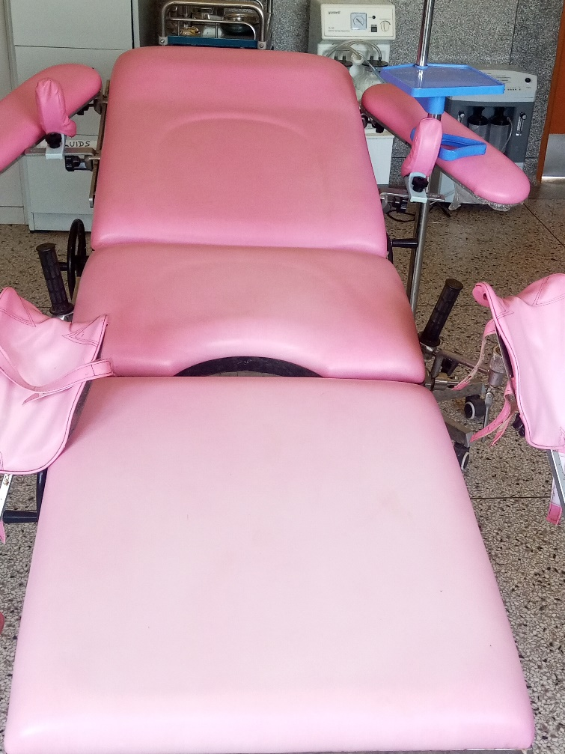

Delivery Bed Hydraulic Manual

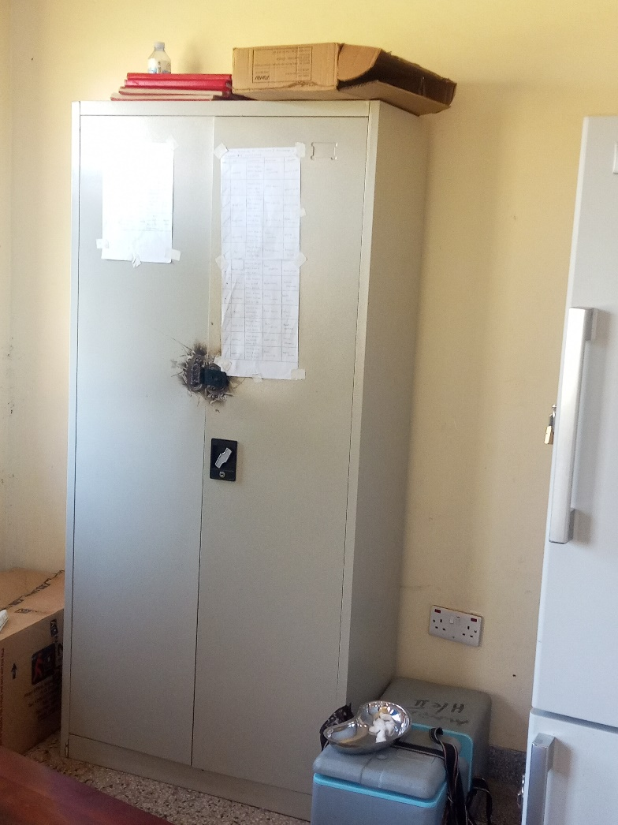

Cupboard Steel Lockable

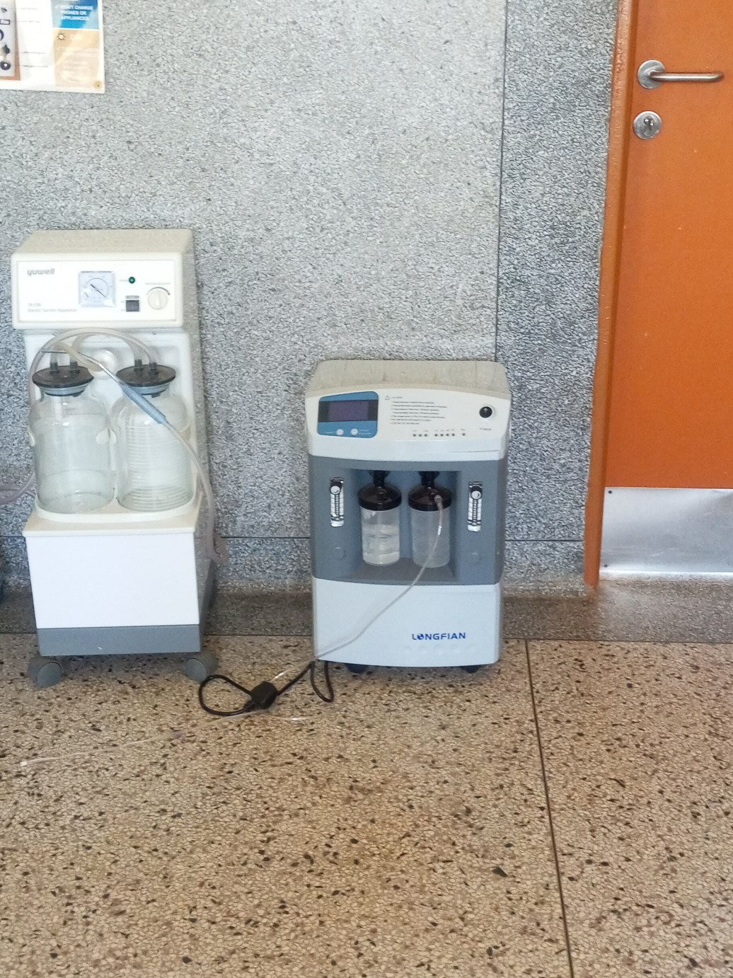

Oxygen Concentrator
Dual Flow

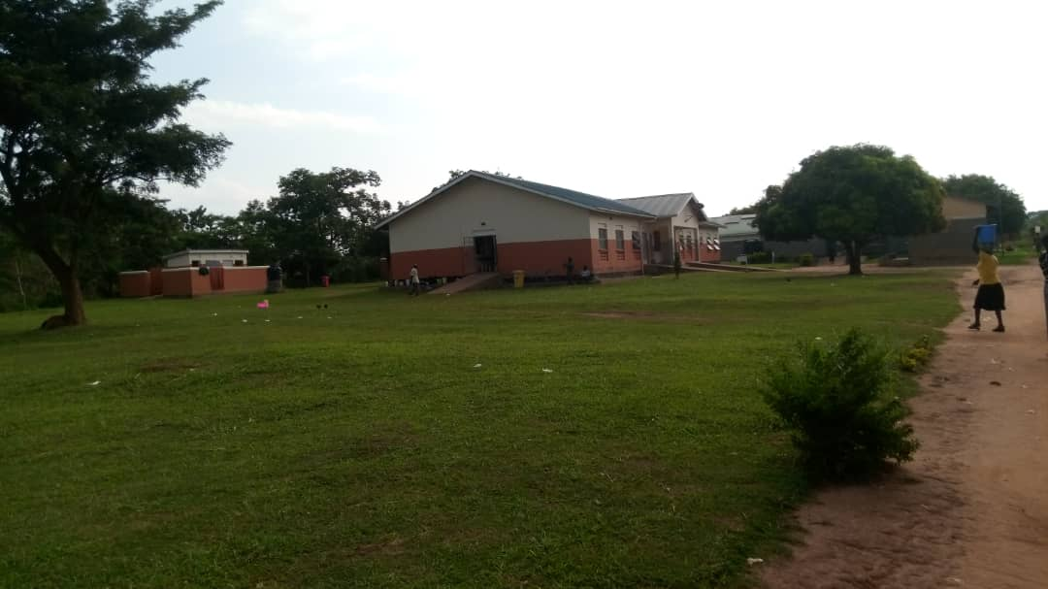

MCH Ward
and
Pit Latrine

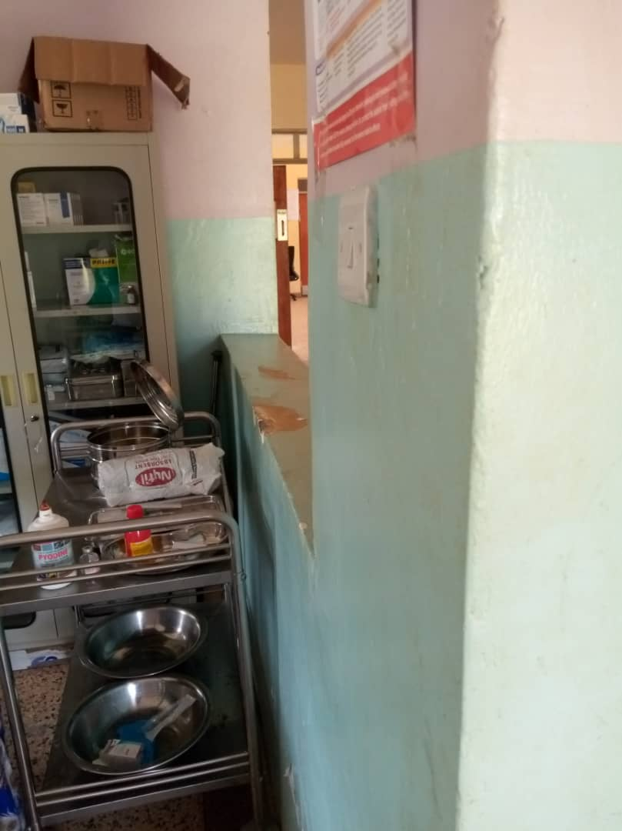

OPD Equipment

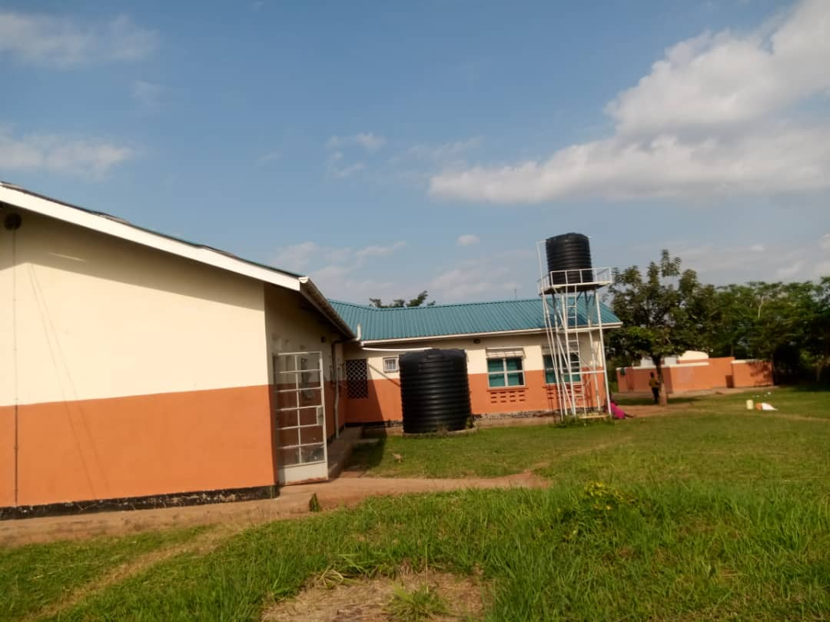

Water Tank

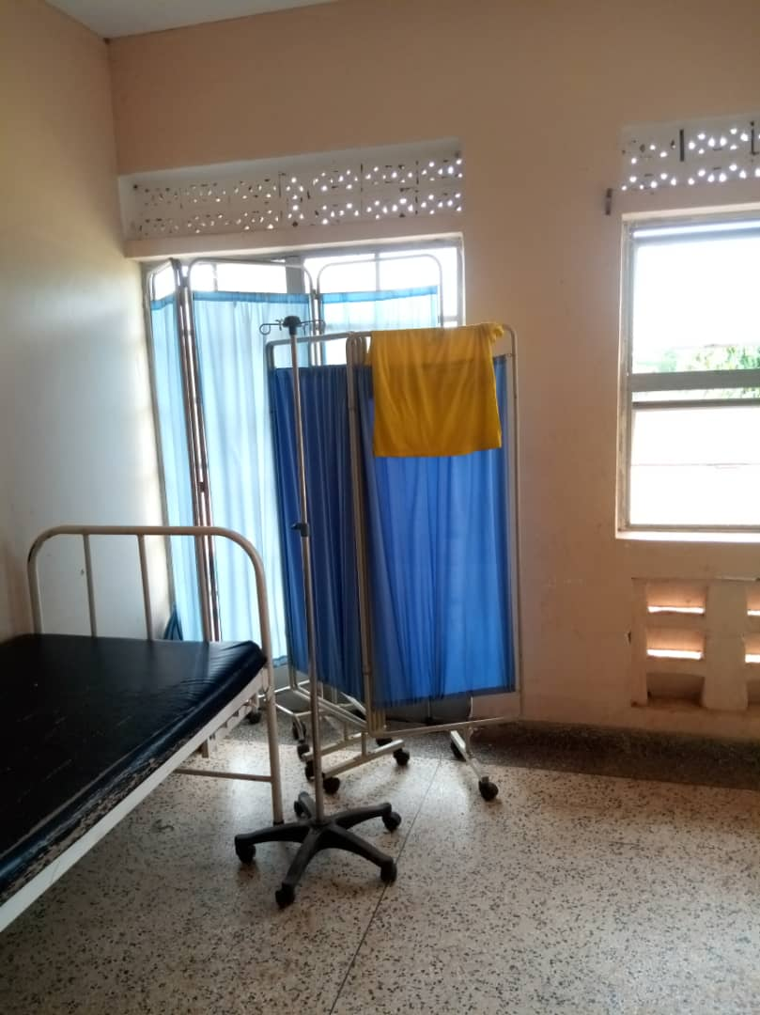

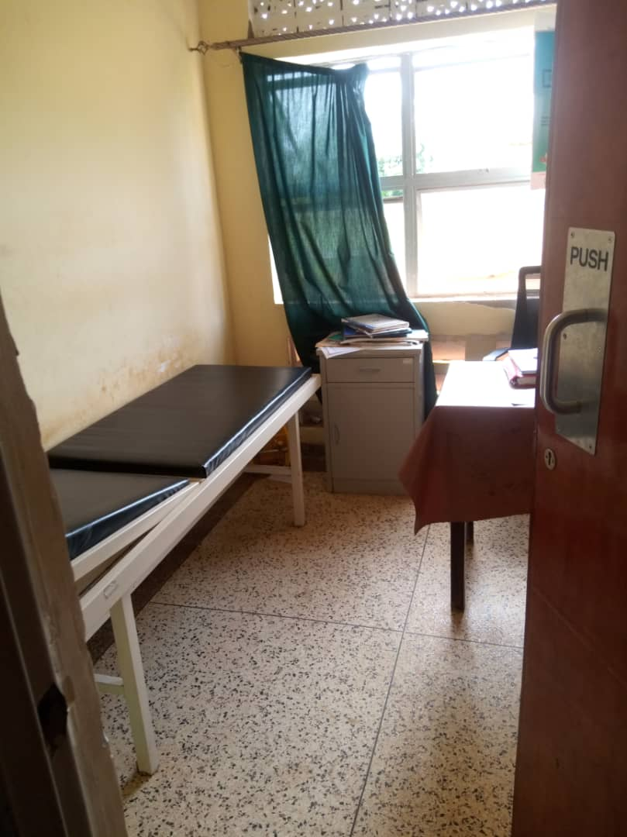

Examination Couch
and
Filing Cabinet

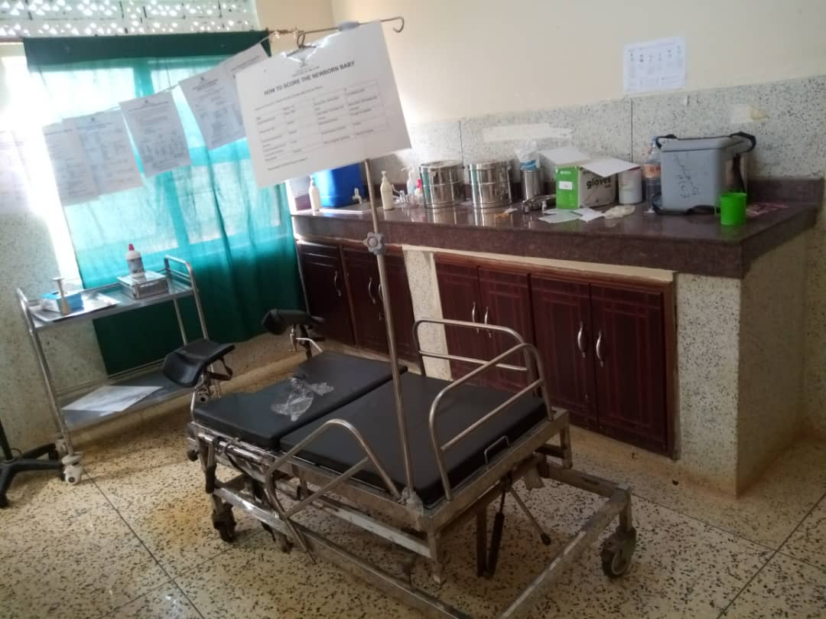

Sample of Equipment
in MCH Ward

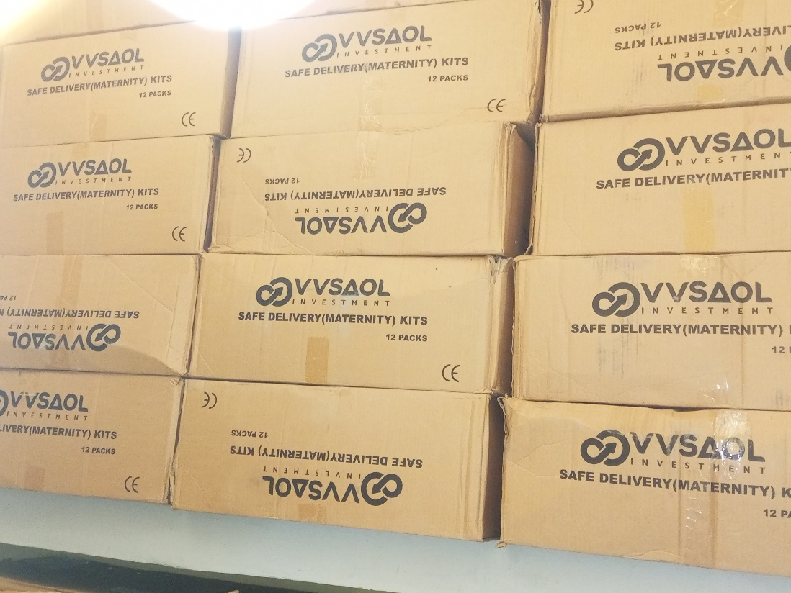

Assets in the Store

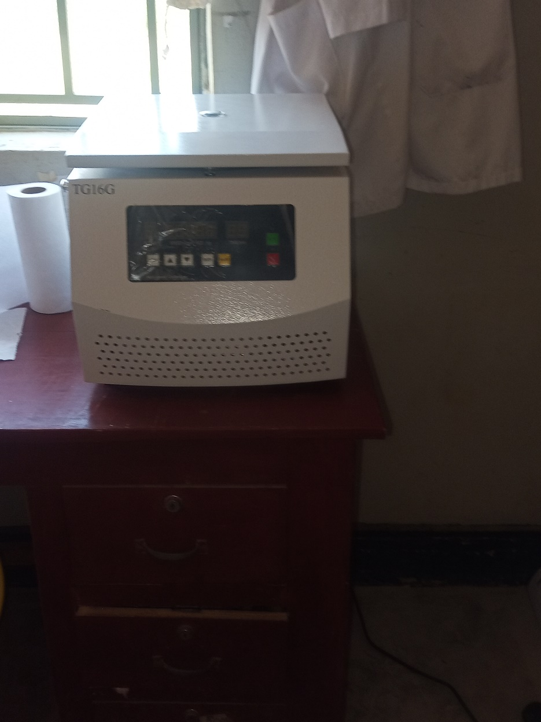

Centrifuge

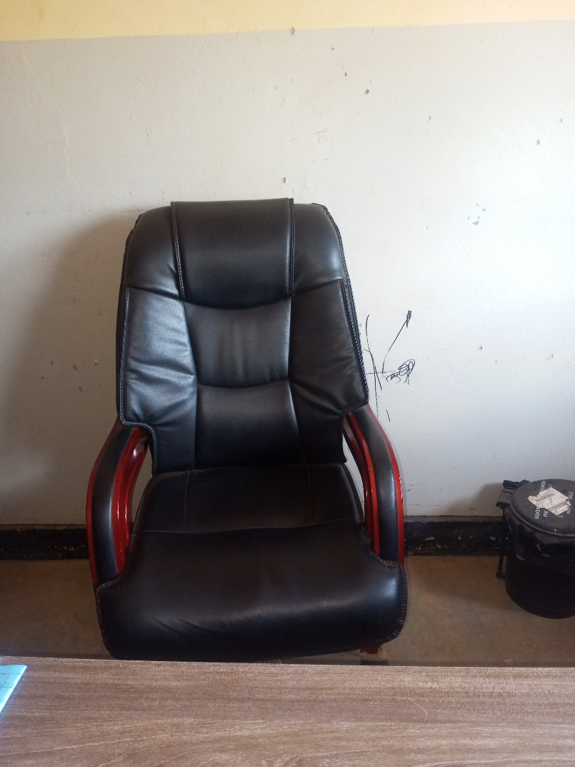

Sample of Office Chair

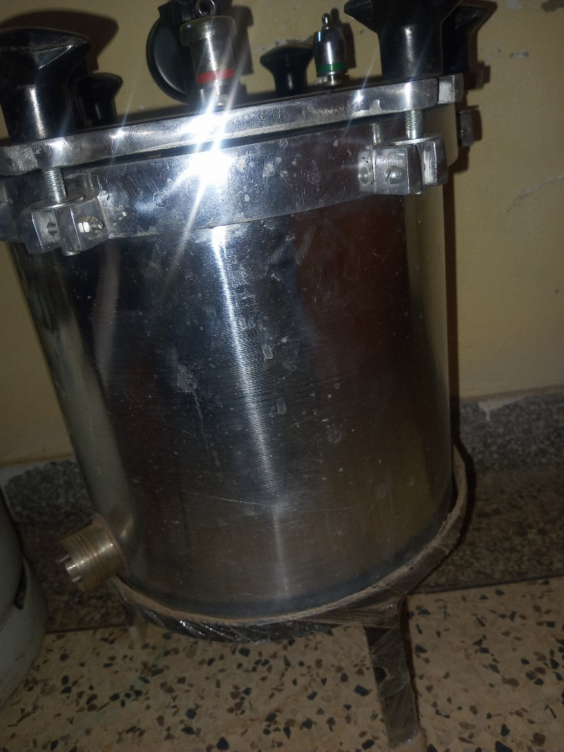

Auto Clave

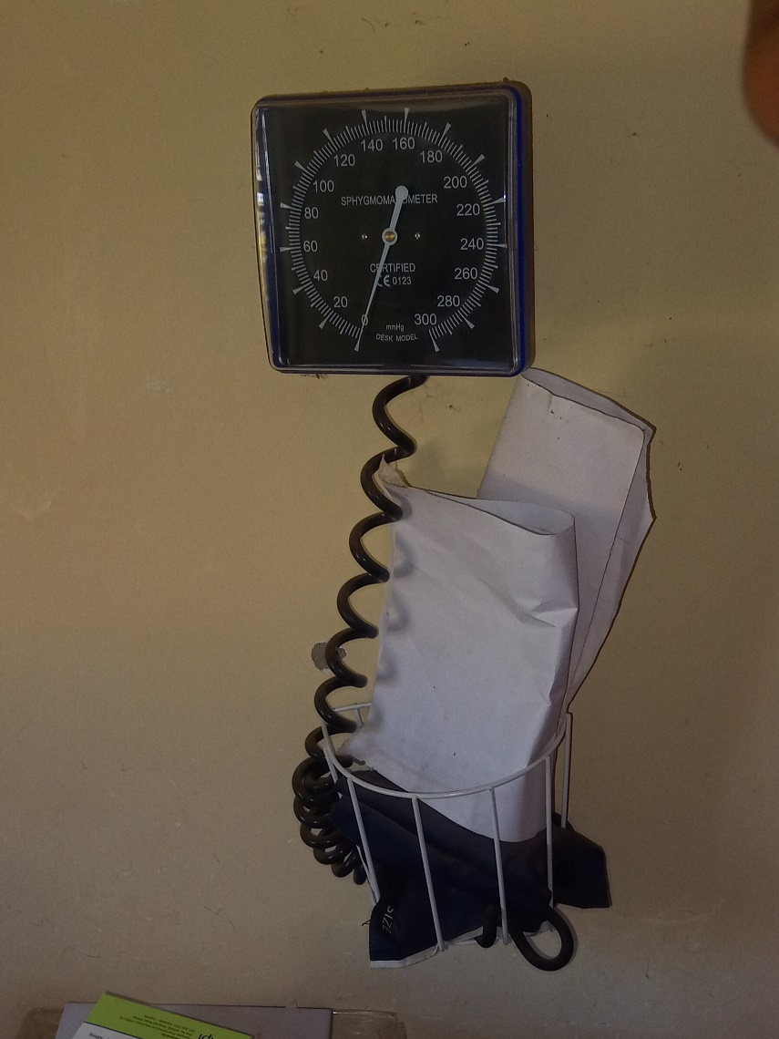

B.P Machine Manual

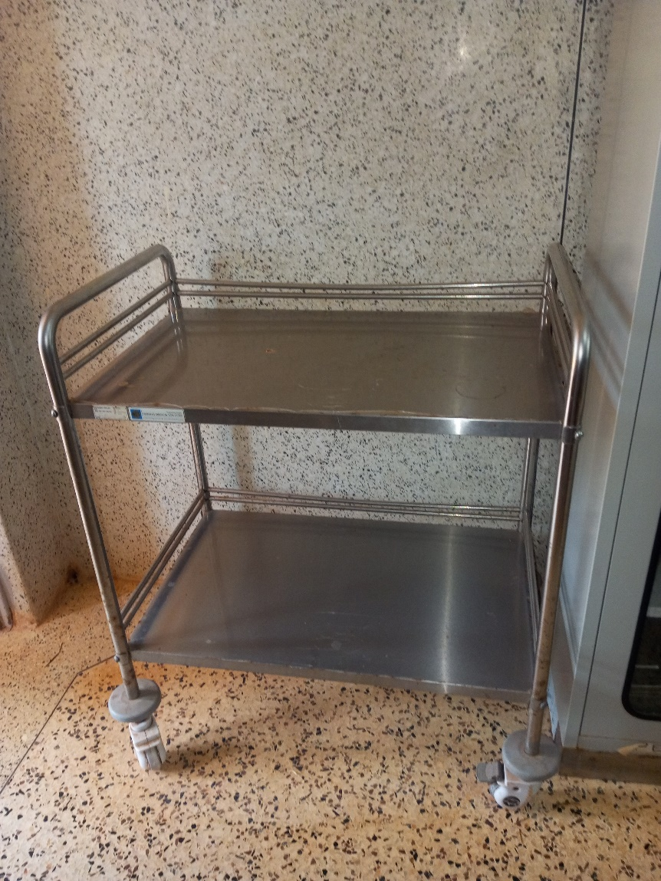

Instrument Trolley

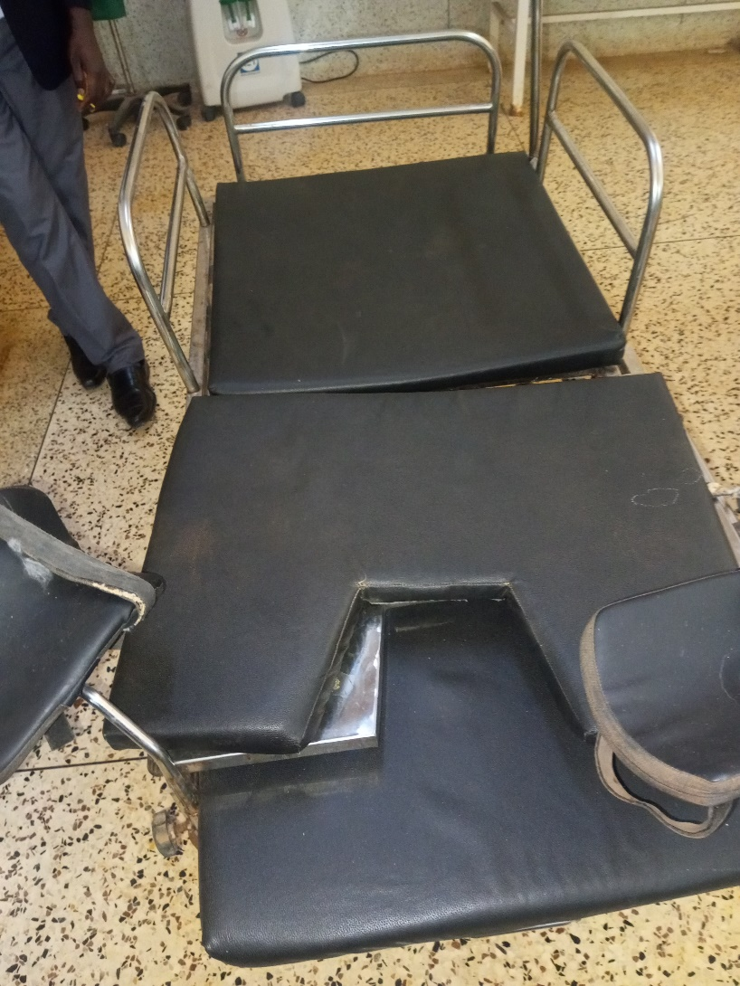

Sample of a Spoilt Bed

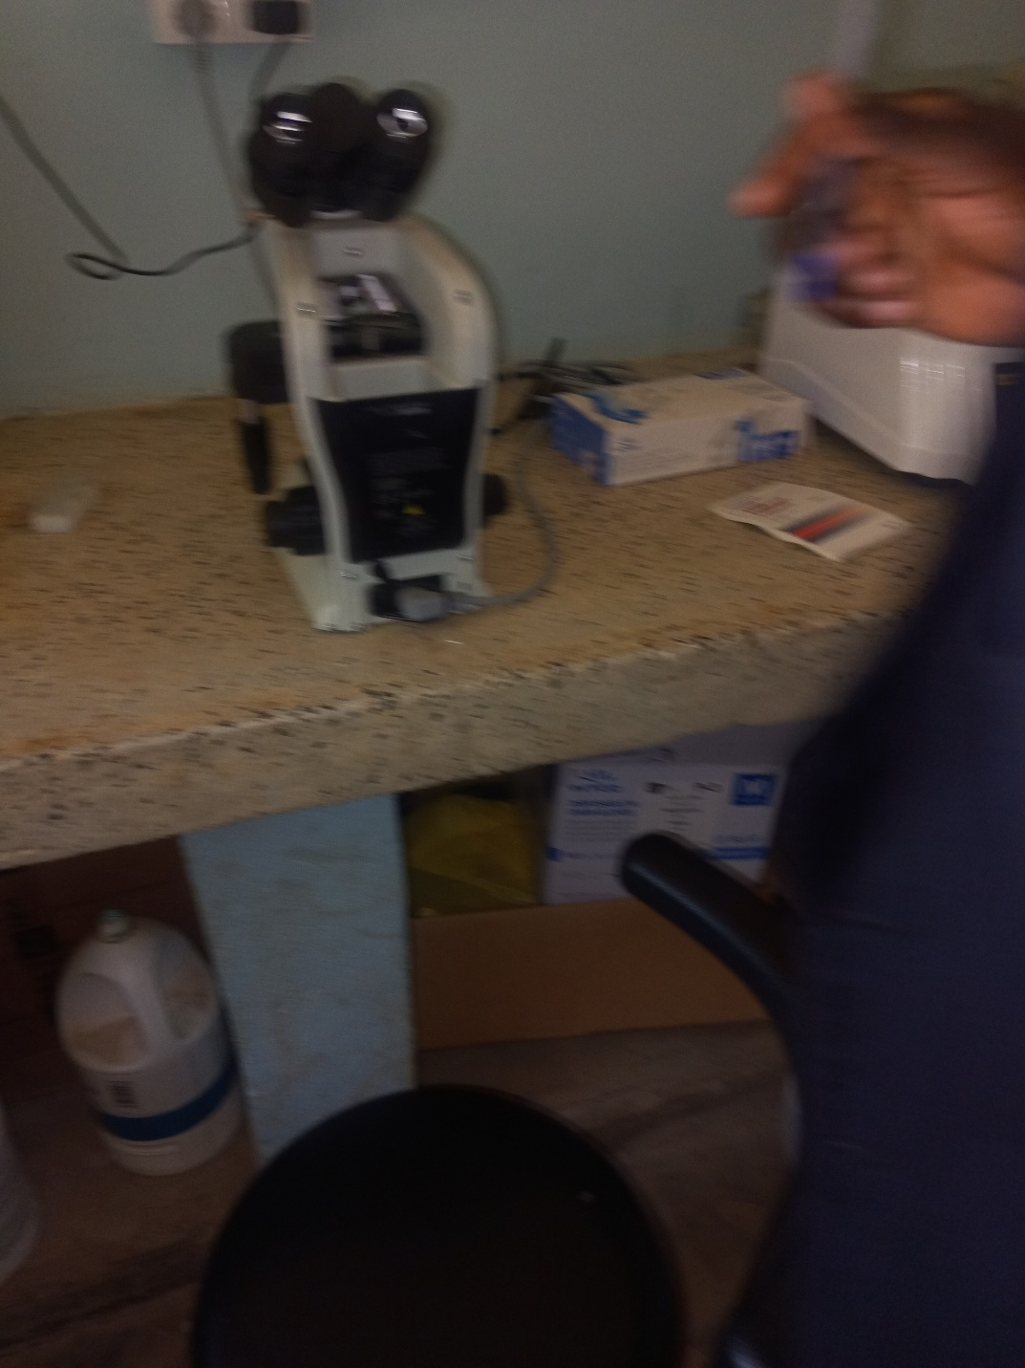

Microscope

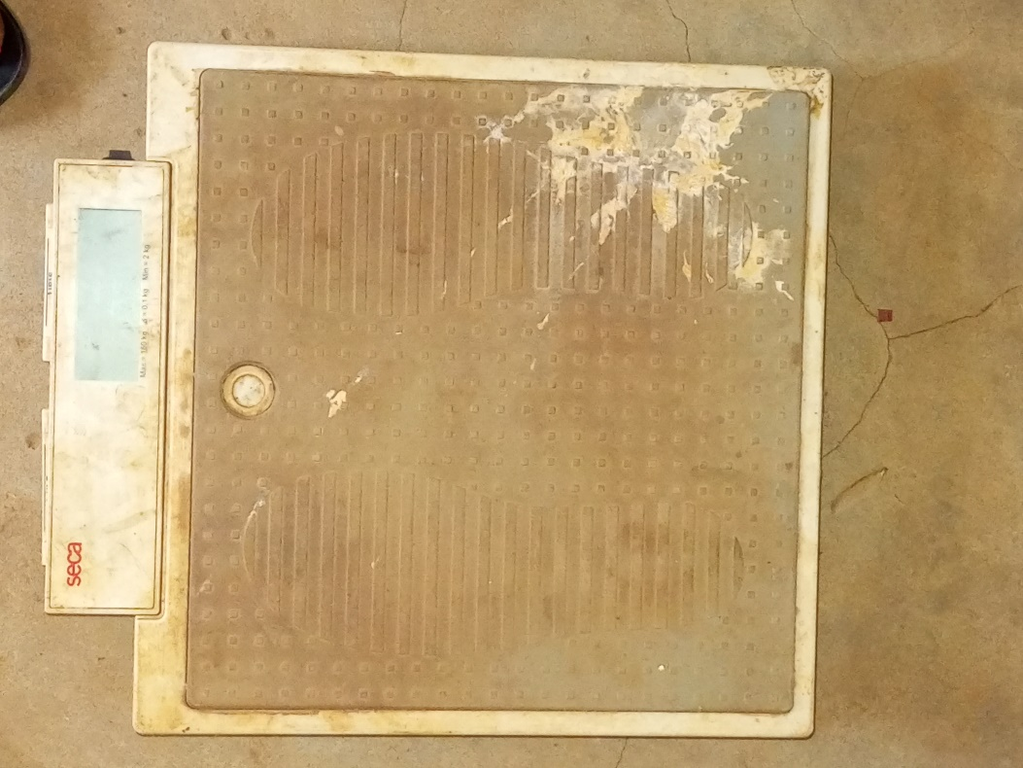

Weighing Scale

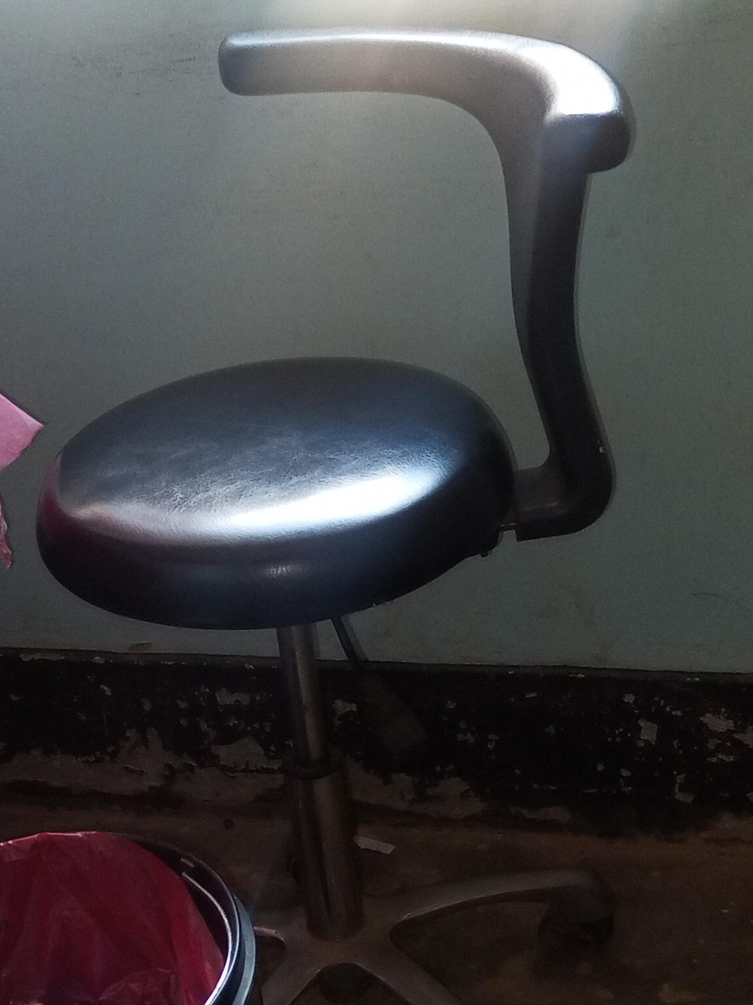

Laboratory
Stool

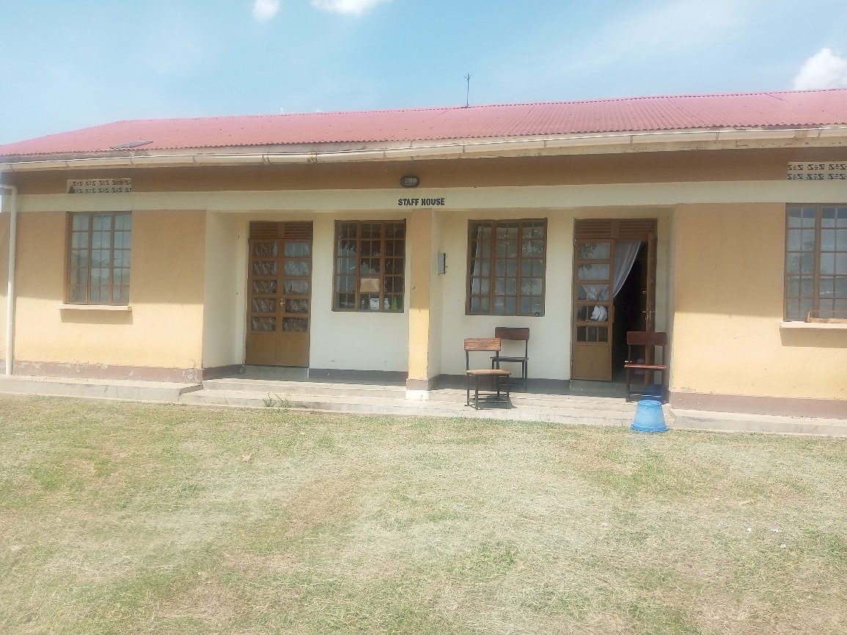

Staff House

SCHOOL VERIFICATION CHECKLIST

SCHOOL INTERVIEW/DISCUSSION GUIDE

Name of school: ………………………………………………………………………………..

1a | Does the Facility have a record of all assets provided under UgIFT.  (Obtain a record and verify if it has the costs and numbers supplied
1b | If Not ask how many were supplied and when.

2 | How does this facility Maintain (repair/service/replace) the assets provided under Ugift

3 | Does the facility take regular record about functionality/ or breakdown of the assets provided?  Nonfunctional/ working, and reasons for non-functionality.

4 | How has the UgIFT support helped in service delivery in the area, any issues, challenges and any recommendations for better program implementation.

PROCEED TO VERIFICATION AFTER THIS DISCUSSION

SCHOOL FURNITURE
(School Desks, Office chairs, Laboratory stools, Book shelves)

Name of LG………………………………………………………………… Name of SCHOOL………………………………………………………………………………

Equipment/ Item | Department | Asset Number | Item  Description | Life in Months | Tag Number ( engrave no.) | Date Of Pur | Date Placed In Service | Recoverable cost | Cost | Acc Dep Cost | Net Book Value | Ytd Deprn | Equipment status | Remarks

ICT ITEMS TO VERIFY
(Desktop Computer, Server Processor, Network Switch 24 Port, Multipurpose Printer, UPS, Projector, Air Conditioners, Server, CCTV Camera)

Name of LG…………………………………………………………………………… Name of SCHOOL………………………….………………………………………

Equipment/ Item | Department | Asset Number | Item  Description | Life in Months | Tag Number ( engrave no.) | Date Of Pur | Date Placed In Service | Recoverable cost | Cost | Acc Dep Cost | Net Book Value | Ytd Deprn | Equipment status | Remarks

BUILDINGS TO VERIFY
(Non- Residential and Residential, Kitchen, Toilets/Pit latrine Water tanks, Fences etc.)

Name of LG…………………………………………………………………………… Name of SCHOOL………………………….………………………………………

Equipment/ Item | Department | Asset Number | Item  Description | Life in Months | Tag Number ( engrave no.) | Date Of Pur | Date Placed In Service | Recoverable cost | Cost | Acc Dep Cost | Net Book Value | Ytd Deprn | Equipment status | Remarks

